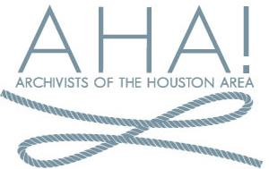
Archivists of the Houston Area
2018 SSA Annual Meeting Scholarship Application

Name Institution
Mailing address

Daytime telephone _____________________
Email _____________________
Signature Date

The Archivists of the Houston Area 2018 SSA Annual Meeting Scholarship will cover the cost of registration for an AHA! member to attend the 2018 Society of Southwest Archivists Annual Meeting May 23 - 26 in San Antonio, TX. This scholarship may only be used toward one registration fee. The winner will be expected to pay their registration and will submit a receipt to the AHA! Treasurer for reimbursement.

Eligibility: Must be a member of the Archivists of the Houston Area (AHA!) and demonstrate a need for assistance. (Membership information and an application are available online at https://houstonarchivists.org/about/membership/)

SCHOLARSHIP APPLICATIONS MUST INCLUDE THE FOLLOWING:

1. Completed application form
2. Completed letter explaining why attending the annual meeting would benefit you, and why outside funding is needed. Include in the letter a brief outline of your archival education and work history, and a description of your long-term professional goals.

Deadline: Mailed applications must be postmarked by April 23, 2018. Emailed applications must be sent by April 30, 2018.

For this inaugural offering, the AHA! Board will function as the Scholarship Committee.

Send completed applications, questions, and comments to AHA! President Matt Richardson:

Matt Richardson
HMRC Photography Archive Supervisor
500 McKinney St. Houston, TX 77002
Matthew.richardson@houstontx.gov

