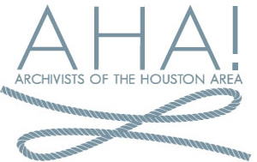

Holiday Party and Meeting
University of St. Thomas-Little Art Gallery
Dec. 10, 2015

Agenda

- Eat and greet

- Welcome

- Presentation
Sandy Hickey-Cofounder and Director of Museum Collections
Houston Blues Museum

- Minutes of July meeting/Secretary’s report

- Treasurer’s report

- President’s report

- Vice-President’s report

- Old Business

- New Business
Elections

