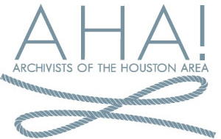
Archivists of the Houston Area!
Board Meeting / Archives Fair Committee Discussion
June 27, 2016

- Intro
  - Present: Andrew Gustafson, Matt Richardson, Emily Vinson, Sandra Yates, Albert Duran, Adrian Melissinos

- Treasurer’s Report
  - Sandra shared budget information, highlighted need for members to pay dues (only 33 so far)

- Organizational questions
  - SSA—did we order an ad in the program? No receipts submitted for reimbursement.
  - RAAC—do we want to pay to support membership in the History Lobby? Decided no, but would be willing to offer letter of support.
- Next general meeting planning
  - Plan for Kinkaid School on July 28. Handbook of Houston to present. Andrew to confirm.
- Archives Fair
  - Reiterated desire to reach out to Austin Archives Bazaar team. Andrew will talk to Billy Glasco about making contact. Would like to coordinate attendance/volunteering at their October event, and hopefully arrange for them to speak at our December meeting.
  - Identified committees for planning our own Fair. Will reach out to membership for volunteers
    - Sponsorships and funding committee
    - Programming committee
    - Location and logistics committee
    - Marketing committee
  - Discussed options for funding, pursuing grants, sponsors, etc.
  - Potential sites identified include: Printing Museum, Nouveau Antique Art Bar, Spring Street, Silos, Brasil

